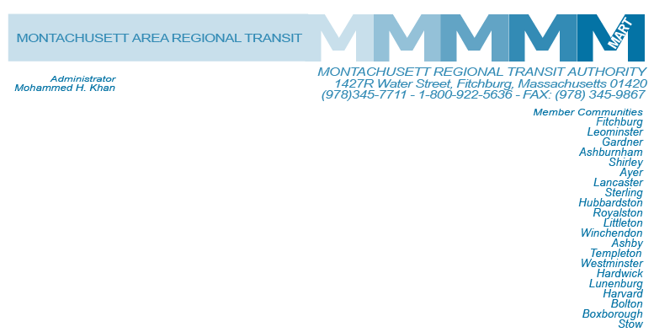

Posted 6.18.2014 at 3:15pm by JAD

MEETING OF THE MART ADVISORY BOARD

**MART Maintenance Facility**

**1427R Water Street**

**Fitchburg, MA 01420**

**Monday, June 23, 2014**

**10:30 A.M.**

### Agenda

1. **Call to Order**
2. **State Retirement Board: Decision relative to Mohammed Khan’s case**
3. **State Retirement: MART joining State Retirement**
4. **Content and Approval of meeting minutes for MART Advisory Board Committees**
5. **Possible addition of non voting members to the MART Advisory Board with experience in IT, Legal and Finance**
6. **Other Business**

# VII. Adjournment

**C: City and Town Clerks: Please post this notice pursuant to MA General Laws Chapter 30A,**

**Sections 18-25.**